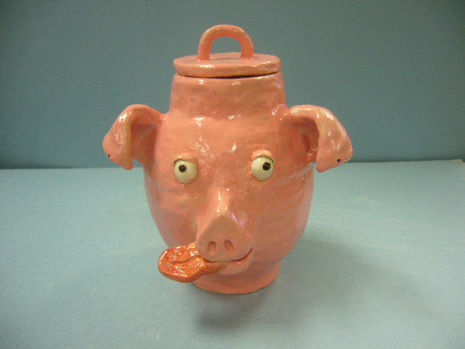
Face Jug
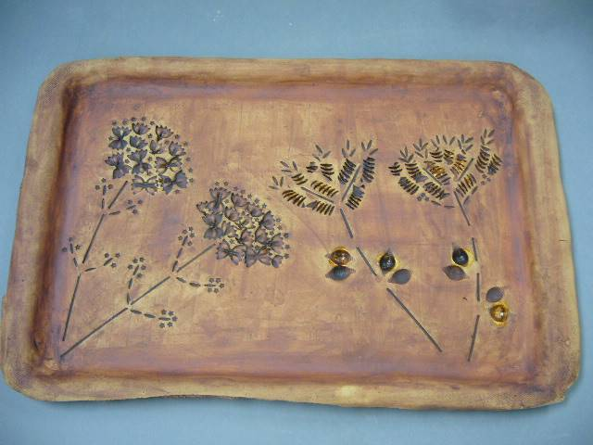
Pasta Platter
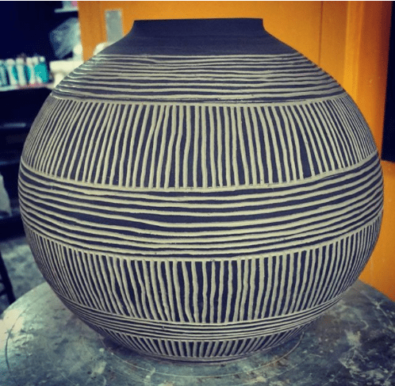
Sgraffito Vessel
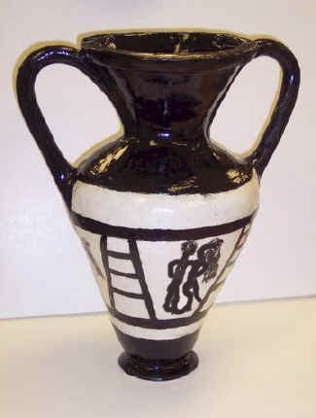
Greek Vessel
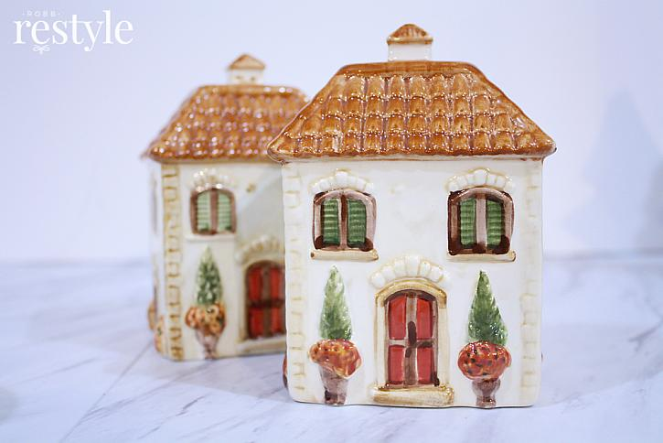
Ceramic Building
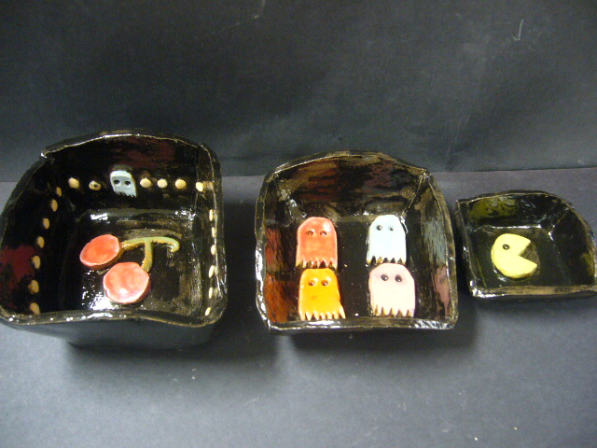
Nesting Bowls
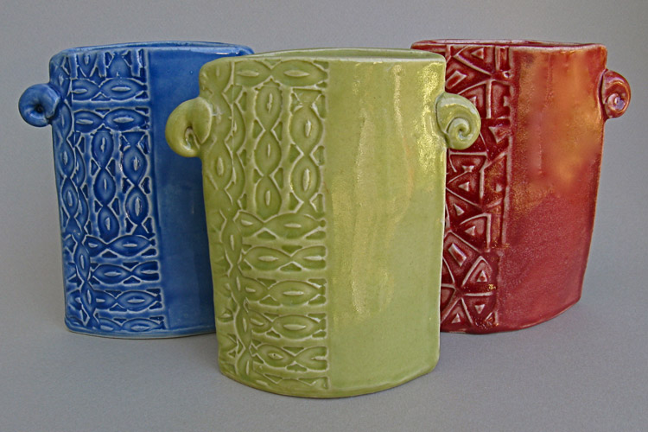
Stamp Pot

Three Choice Projects

Depending on how much time you spend on the required projects, you will have time to complete your choice projects.
Three choice projects are required during the semester. You may make more if time allows.
Choice projects must have teacher approval. They must be complex and challenging enough for your level and must be no more than 6” x 6” x 6”.
See me if you have questions regarding choice projects.

