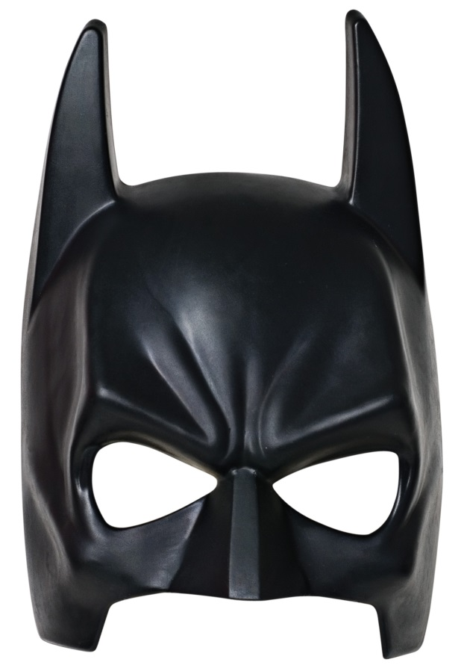
MASKERAID
5/6 8-11
Spartan Stadium's Huntington Club

